1. Handling Missing Values:

Check for missing values in the 'Price' column. How would you handle products with missing price information?
Missing values in the price column
3
How would you handle products with missing price information?
I handle in two way
1. Missing place I fill the value in "0"
2. I find out the median value of price column is "130"
MEDIAN(D2:D35)
130

If there are products with missing categories, propose a strategy to impute or deal with these missing values effectively.
If there are products with missing categorie
4
propose a strategy to impute or deal with these missing values effectively.
I compard each product with similar product that already had a category in the dataset and used the existing category for the missing value.
Backpack == Accessories
Sneakers == Fashion
Coffee Maker == Kitchen
Fitness Tracker == Electronics

2. Correcting Inconsistent Data:
Identify any inconsistent text formats present in the "Product Name" column.
I created the new column "NEW PRODUCT NAME"
I used PROPER function

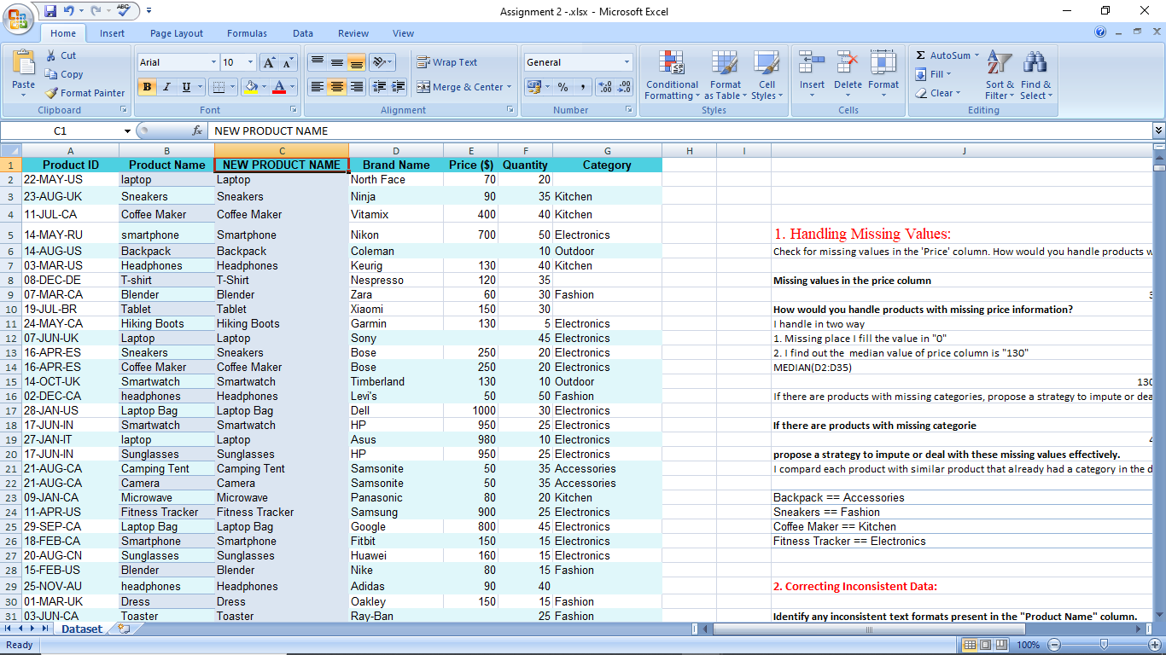

Identify any typos present in the "Category" column.
Electroni ==> Electronics
I used Crtl+H replace method
Use the find and replace function to standardize the text formats in the "Product Name" column and fix any typos or misspellings in the "Category" column.
Laptop, Smartphone, Sneakers,and ect.
I used Crtl+H replace method

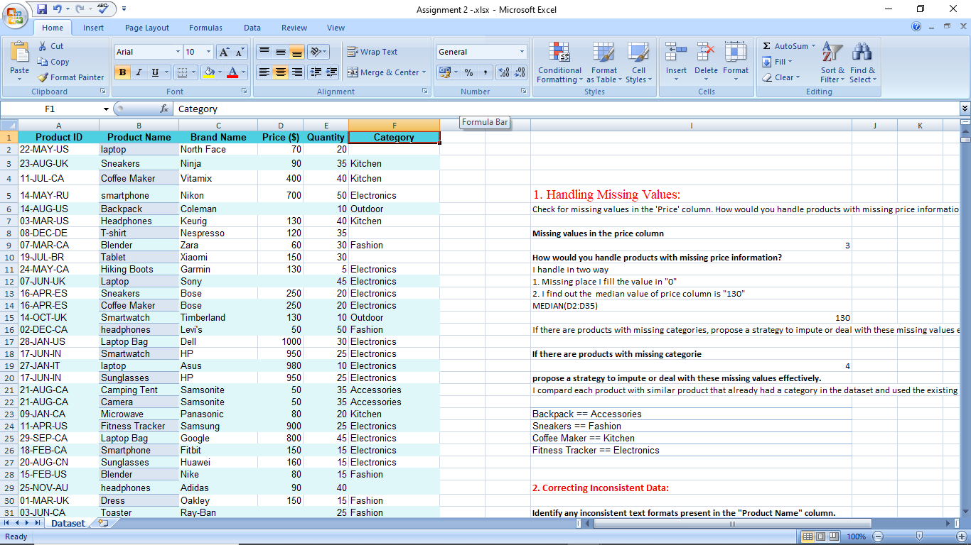

3. Removing Duplicates:
Identify any duplicate rows within the dataset based on the entirety of each row, and remove them if any.
No duplicate rows

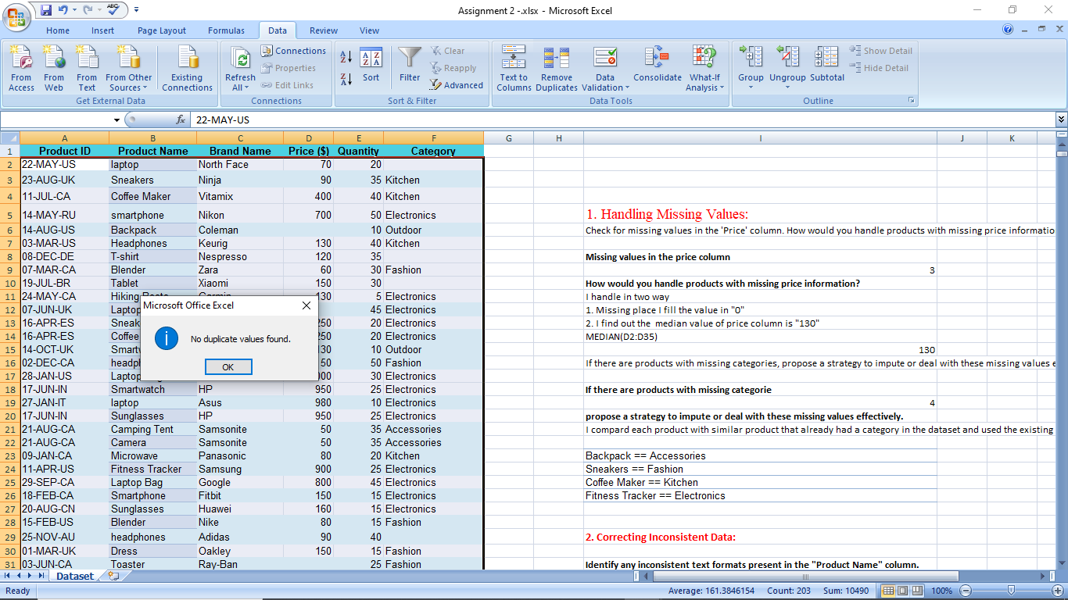

4. Splitting and Merging Data:
Split the "Product ID" column into two separate columns for " Manufacturing Date" and "Country Code". Remove unnecessary characters, if any.

First i split the column used to delimited option then split the three columns but i want the two columns so then i did "CONCANATE" function used to combine the two columns.

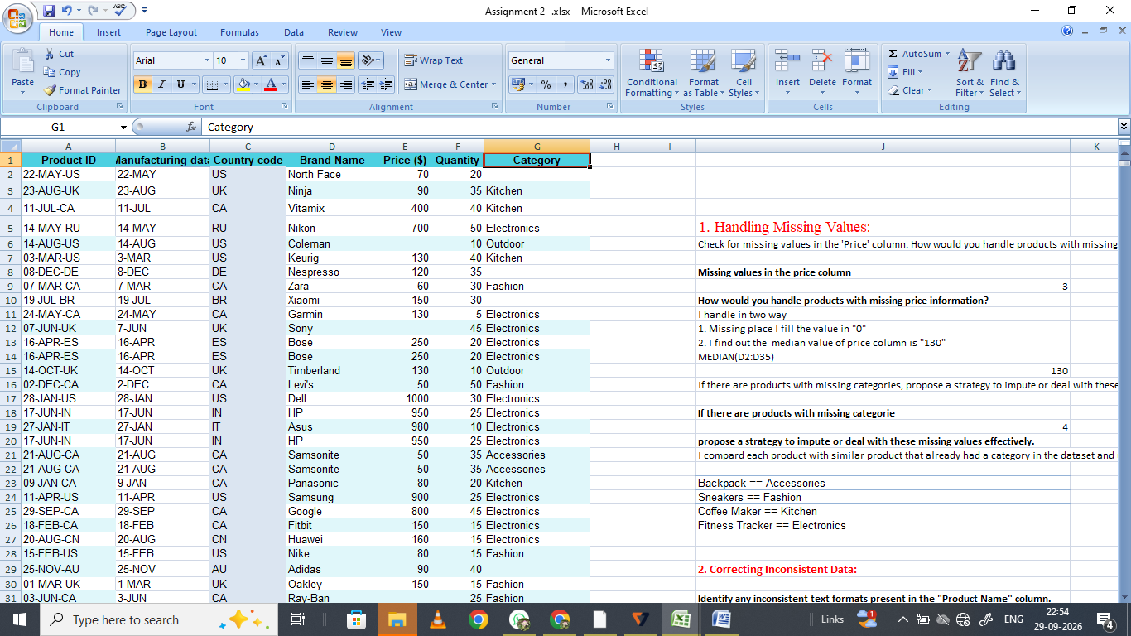

Merge the "Brand Name" and "Product Name" columns into one column named "Product Brand"
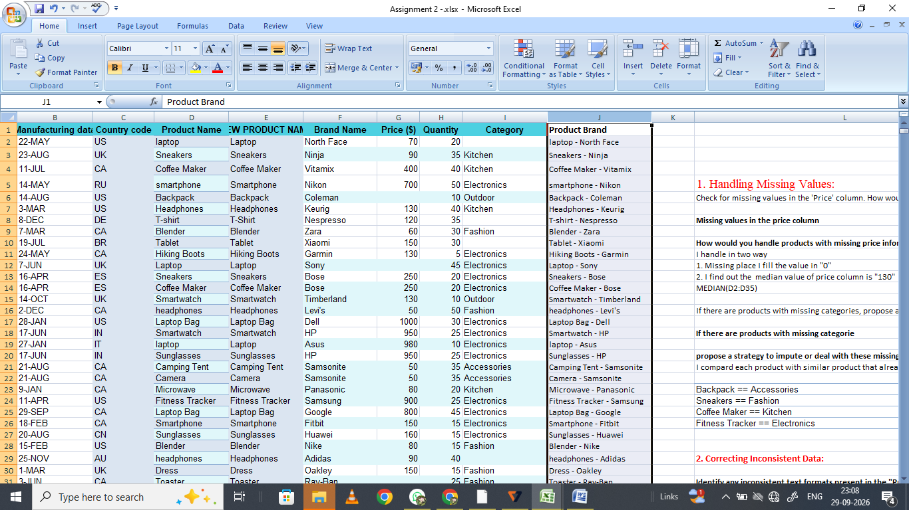

5. Number Formatting:
Format the data type of the "Price" column to a currency format.
Go to home menu => Number section => click $Currency button.
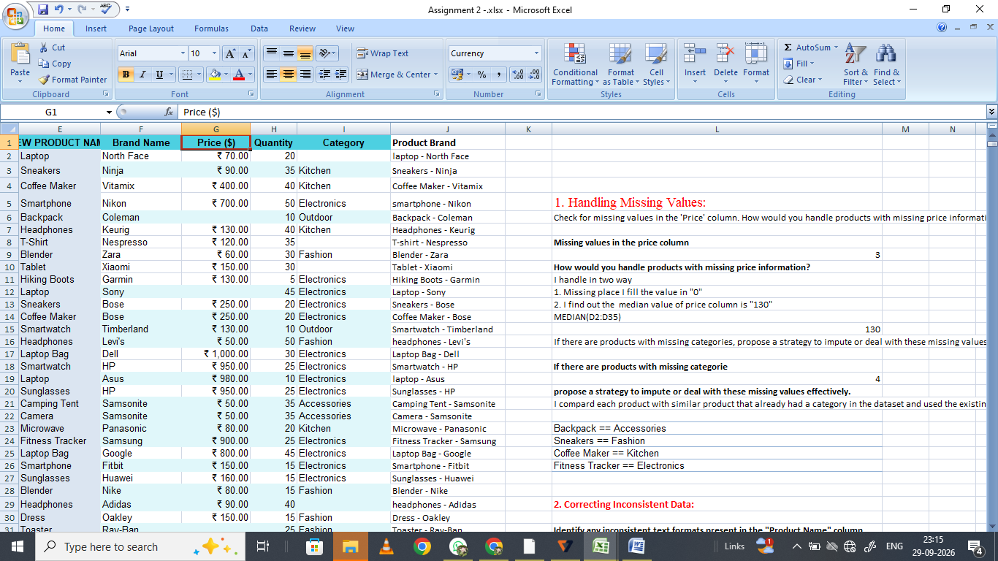
Format the "Manufacturing Date" column to display dates in the "DD-MM-YYYY " format.
This data set not give the year this gives the day and month, but does not give a year so cannot display the date format "DD-MM-YYYY".

6. Conditional Formatting:
Apply data bar or color scales conditional formatting in the "Price" column.
Select price column => home tab => conditional formatting => Data bars => choose any bar style.

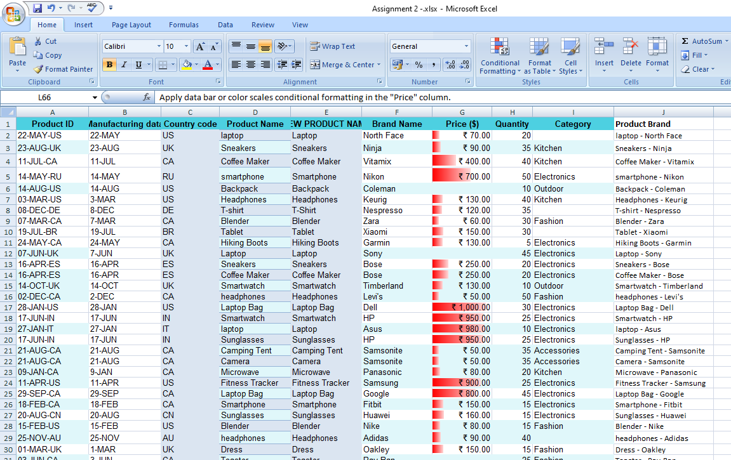

Create a custom rule for conditional formatting in the "Category" column to highlight cells where the category is "Electronics."
Select the category column => home tab => conditional formatting => highlight cells => show the pop up => choose the font style and color and choose cell fill color.

